23CSE111

OBJECT ORIENTED PROGRAMMING

LAB MANUAL


Department of Computer Science and Engineering Amrita School of computing
Amrita Vishwa Vidyapeetham, Amaravati Campus

Verified by: NAME: M. GAURAV
ROLLNO: AV.SC.U4CSE24212

S.No. | Experiment Name | Page No. | Remarks | Signature
1 | Installation Process of JDK | 3-6
2 | Simple Java Program for printing basic details of student | 6-10
3 | Simple java programs | 10-21

WEEK-1

- How to download and install java software in your computer.
1.Steps for downloading.
Step 1: Java is developed by oracle. so, open your web browser and search for java oracle.
Step 2: Then go to the website https://www.oracle.com/in/java/ .
Step 3: And navigate to the java downloads. Then some earlier versions are available like
- JDK 23
- JDK 21
- GraalVM for JDK 23
- GraalVM for JDK 21
Step 3: JDK 21 is the latest Long-Term Support (LTS) release of the Java SE Platform. So, we use this version.
Step 4: According to your device operating system choose the product/file description.
Step 5: Then the version will be automatically downloaded.
2.Steps for installation.
Step 1: Go to the folder where it was downloaded.
Step 2: Then open and accept all terms and conditions.
Step 3: And install it.

3.Setting environmental variables.
Step 1: Open file explorer, then right click on This PC next select on properties then it will take you to the settings app then click on advanced system settings and then click on Environment Variables.
Step 2: Click New under System Variables:
    - Set Variable name as: java_home
    - Variable value: The folder address where JDK is installed (like C:\Program Files\Java\jdk-21\bin)
Step 3: Find Path under System Variables, click Edit, and add the path of the jdk-21(D:\UNI+\EDU\JAVA)

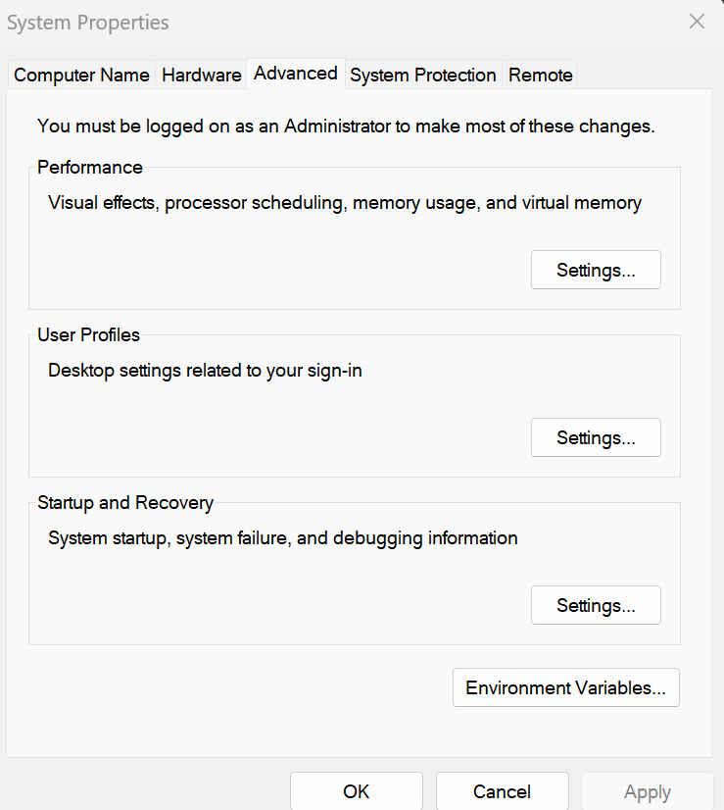

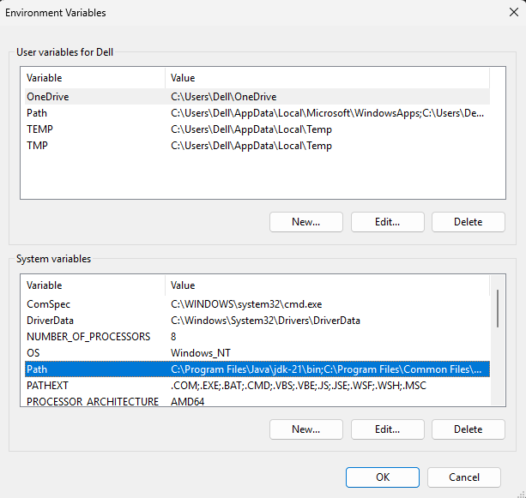

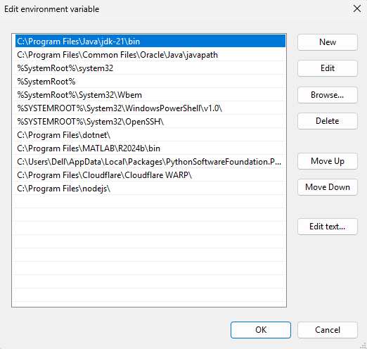
4.Checking for jdk(java development kit) version.
Step 1: Open command prompt.
Step 2: Enter javac --version for version of jdk installed.
Step 3: Enter java –version for all details like when downloaded and path of environment variables
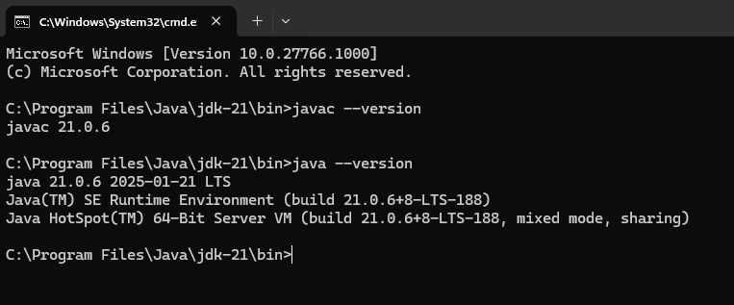
a ) write a simple java program to print your name, roll no,sec etc.

Program :

class Demo
{
public static void main(String[] args)

{
System.out.println("NAME= M. GAURAV");
System.out.println("ROLL NO= AV.SC.U4CSE24212");
System.out.println("SEC= C");
System.out.println("BRANCH= CSE");
}
}

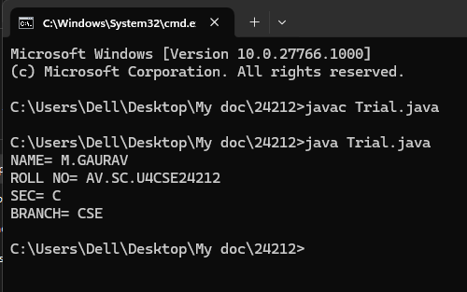
Errors:

S.NO | Error Name | Error Rectification
1 | Syntax/ Compilation Error | Trial.java:6: error: ';' expected  System.out.println("NAME= M.GAURAV")  ^  1 error

WEEK -2 (LAB)
SIMPLE JAVA programs
- WRITE A JAVA PROGRAM TO FIND AREA OF RECTANGLE
Program:
import java.util.*;
class area
{
public static void main(String args[])
{
int area;
Scanner sc = new Scanner(System.in);
System.out.println("Enter Length:");
int l = sc.nextInt();
System.out.println("Enter Breadth:");
int b = sc.nextInt();
area = l*b;
System.out.println("Area of Rectangle :"+area);
}
}

Output:
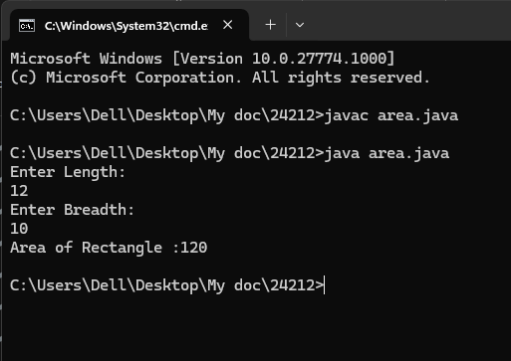
Error:
1 | Syntax error | area.java:7: error: ';' expected  Scanner sc = new Scanner(System.in)  ^  1 error

- WRITE A JAVA PROGRAM TO CALCULATE SIMPLE INTREST:

import java.util.*;
class Simpleinterest{
public static void main(String[] args)
{
System.out.println(" taking input");
Scanner sc = new Scanner(System.in);
System.out.println("enter INTa number:");
float p = sc.nextFloat();
System.out.println("enter a number:");
float t = sc.nextFloat();
System.out.println("enter a num:");
float r = sc.nextFloat();
float s = (p*t*r)/100;
System.out.println("simple intrest is"+s);
}
}
Output:
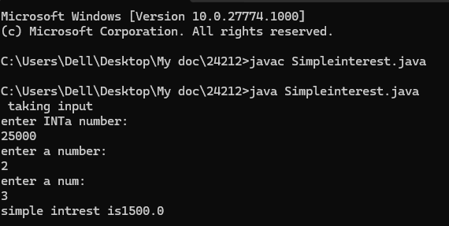

Error:
S.No | Error type | Reason for error
1 | Runtime error | error: file not found: Simpleinterest.java  Usage: javac <options> <source files>  use --help for a list of possible options

- WRITE A JAVA PROGRAM TO FIND FIBNOACCI SERIES:
Program:
import java.util.*;
class fibo
{
public static void main(String args[])
{
Scanner sc = new Scanner(System.in);
int num;
int f3;
int f1 = 0;
int f2 = 1;
int i = 2;

System.out.print("Enter a number:");
num = sc.nextInt();
System.out.println(f1);
System.out.println(f2);

while(i<num)
{
f3 = f1+f2;
f1 = f2;
f2 = f3;
System.out.println(f3);
i = i+1;
}
}
}
Output:
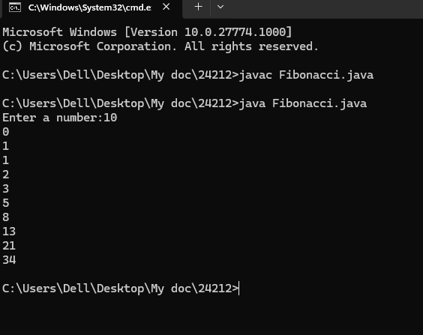
Error:
S.No | Error type | Reason for error
1 | Runtime error | error: file not found: Fibonacci.java  Usage: javac <options> <source files>  use --help for a list of possible options

- WRITE A JAVA PROGRAM TO CALCULATING TEMPERATURE IN CELSIUS
Program:
import java.util.*;
class temp
{
public static void main(String args[])
{
Scanner sc = new Scanner(System.in);
float c;
System.out.println("Enter Fahrenheit Temperature:");
float f = sc.nextFloat();
c = (f-32)*5/9;
System.out.println("celcius Temperature is :"+c);
}
}
Output:
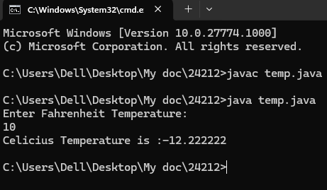
Error:
S.No | Error type | Reason for error
1. | Syntax | temp.java:7: error: ';' expected  Scanner sc = new Scanner(System.in)

- WRITE A JAVA PROGRAM TO FIND FACTORIAL OF A GIVEN NUMBER
Program:
import java.util.*;
class Fact
{
public static void main(String args[])
{
int number;
Scanner sc = new Scanner(System.in);
System.out.println("Enter a number:");
number = sc.nextInt();
System.out.println("Enter time:");
int answer = factorial(number);
System.out.println("factorial of"+ number + " is " + answer);

} static int factorial(int n){
if(n==1)
{
return 1;
}
return n * factorial(n-1);

}
}
Output:
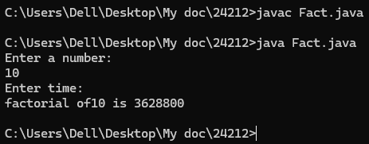

Error:
S.No | Error type | Reason for error | rectification
 | Logical error | Incorrect input | Correcting input
 | Runtime error | Incorrect path | Using correct path

- WRITE A JAVA PROGRAM TO CONVERTE CELSIUS TO FAHRENHEIT:
Program:
import java.util.*;
class heat
{
public static void main(String args[])
{
Scanner sc = new Scanner(System.in);
float f;
System.out.println("Enter Celsius Temperature:");
float c = sc.nextFloat();
f = (c*9/5)+32;
System.out.println("Fahrenheit Temperature is :"+f);
}
}
Output:
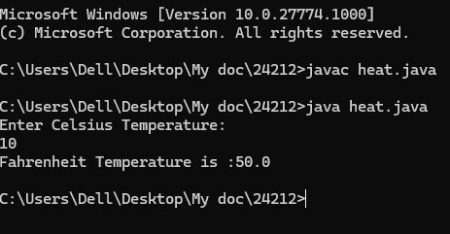
Error:

S.No | Error type | Reason for error | rectification
1. | Logical error | Incorrect input | Correcting input

- WRITE A JAVA PROGRAM TO CALCULATING AREA OF TRIANGLE USING HERONS’ FORMULA:
Program:
import java.util.*;
import java.lang.Math;

class Triangle{
public static void main(String[] args) {
double s, c, a, b, p;
Scanner sc = new Scanner(System.in);
System.out.println("Enter the value of a, b, and c:");
a = sc.nextDouble();
b = sc.nextDouble();
c = sc.nextDouble();
s = (a + b + c) / 2;
p = Math.sqrt(s * (s - a) * (s - b) * (s - c));
System.out.println("Area of triangle by Heron's formula is = " + p);
}
}

Output:
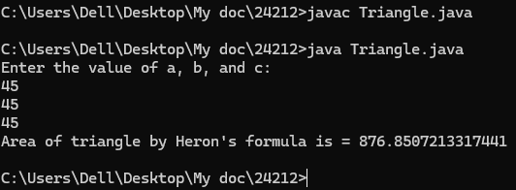
Error:

S.No | Error type | Reason for error | rectification
1. | Logical error | Incorrect input | Correcting input

WEEK -3
WRITE A JAVA PROGRAM TO CREATE A CLASS WITH CAR NAME:

PROGRAM:

class Main {
String car_color;
String car_brand;
String fuel_type;
int mileage;

// Constructor
public Main(String car_color, String car_brand, String fuel_type, int mileage) {
this.car_color = car_color;
this.car_brand = car_brand;
this.fuel_type = fuel_type;
this.mileage = mileage; // Fixed the spelling mistake here
}

// Getter methods
public String color() {
return car_color;
}

public String brand() {
return car_brand;
}

public String fuel() {
return fuel_type;
}

public int mile() {
return mileage;
}

// Main method
public static void main(String[] args) {
Main car1 = new Main("red", "Hyundai", "diesel", 19);
System.out.println("Car 1 - Color: " + car1.color() + ", Brand: " + car1.brand() +
", Fuel Type: " + car1.fuel() + ", Mileage: " + car1.mile());

Main car2 = new Main("blue", "Toyota", "petrol", 17);
System.out.println("Car 2 - Color: " + car2.color() + ", Brand: " + car2.brand() +
", Fuel Type: " + car2.fuel() + ", Mileage: " + car2.mile());

Main car3 = new Main("black", "Tata", "diesel", 19);
System.out.println("Car 3 - Color: " + car3.color() + ", Brand: " + car3.brand() +
", Fuel Type: " + car3.fuel() + ", Mileage: " + car3.mile());
}
}

Output:

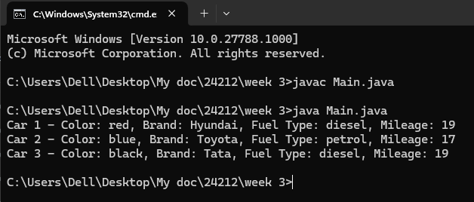
Error:

S.No | Error type | Reason for error
1. | Identifier error | Main.java:3: error: <identifier> expected  car_brand;  ^  1 error

WRITE A JAVA PROGRAM TO CREATE A CLASS BANK ACCOUNT WITH METHODS DEPOSIT AND WITHDRAWAL:

PROGRAM:
class Bank_Account {
private String accname;
private int acno;
private float balance;

// Constructor
public Bank_Account(String accname, int acno, float balance) {
this.accname = accname;
this.acno = acno;
this.balance = balance;
}

// Withdraw method
public void withdraw(int amount) {
if (amount <= balance) {
balance -= amount;
System.out.println("Withdrawal of " + amount + " successful. Remaining balance: " + balance);
} else {
System.out.println("Insufficient balance for " + accname);
}
}

// Deposit method
public void deposit(int amount) {
balance += amount;
System.out.println("Deposit of " + amount + " successful. Updated balance: " + balance);
}

// Method to display account details
public void displayDetails() {
System.out.println("Account Name: " + accname);
System.out.println("Account Number: " + acno);
System.out.println("Balance: " + balance);
}

public static void main(String[] args) {
Bank_Account s = new Bank_Account("Anil", 34571, 25000);
s.withdraw(20000);
s.deposit(2000);
s.displayDetails();

System.out.println(); // Just for better readability

Bank_Account s1 = new Bank_Account("Jeevan", 333226, 25000);
s1.withdraw(2500);
s1.deposit(250000);
s1.displayDetails();
}
}
OUTPUT:
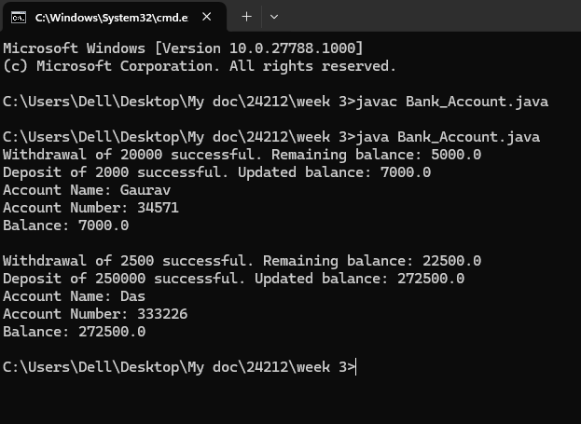
ERROR:
S.No | Error type | Reason for error
1. | Syntax | Bank_Account.java:7: error: ';' expected  Scanner sc = new Scanner(System.in)

WEEK-4
TO CREATE A JAVA PROGRAM WITH CLASS NAMED “MYCLASS” WITH A STATIC VARIABLE COUNT OF “INT” TYPE ,INSIZED TO “ZERO” AND A CONSTANT VARIABLE “PI” OF TYPE “DOUBLE” INITIALIZED TO 3.1415 AS ATTRIBUTES OF THAT CLASS . DEFINE A CONTRUCTOR FOR “MYCLASS” IS CREATED FINALLY PRINT THE FINAL VALUES “COUNT” AND “PI” VARIABLES.
PROGRAM:
public class MyClass {
public static int count = 0;
public static final double PI = 3.14;

public MyClass() {
count++;
}

public static void main(String[] args) {
MyClass obj1 = new MyClass();
MyClass obj2 = new MyClass();
MyClass obj3 = new MyClass();

System.out.println("Count: " + count);
System.out.println("PI: " + PI);
}
}
OUTPUT:
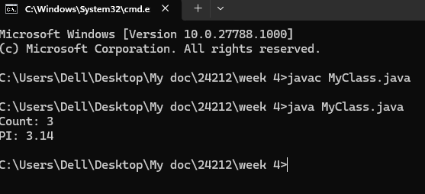
Error:
S.No | Error type | Reason for error
1. | Syntax | MyClass.java:7: error: ';' expected  Scanner sc = new Scanner(System.in)

CLASS DIAGRAM
MyClass
- count: int (static)
- pi: double (static final)

+ MyClass()
+ main(String[] args): void

Aim:TO CREATE A JAVA PROGRAM WITH CLASS NAMED” BOOK”. THE CLASS SHOULD CONTAIN VARIOUS ATTRIBUTES SUCH AS “TITLE OF THE BOOK”, “AUTHOR”, YEAR OF PUBLICATIONS”, IT SHOULD ALSO CONTAIN A CONSTRUCTOR WITH PARAMETER WHICH INITIALIZES “TITLE OF THE BOOK”, “AUTHOR”, “YEAR OF PUBLICATION”. CREATE A METHOD WHICH DISPLAYS THE DETAILS OF THE BOOK. TITLE OF THE BOOK (), AUTHOR (), YEAR OF PUBLICATION ().DISPLAY THE DETAILS OF TWO BOOK, BY CREATING 2 OBJECTS.
PROGRAM:
class book{
public String title;
public String author;
public int year_of_publication;

public book(String title, String author, int year_of_publication){
this.title = title;
this.author = author;
this.year_of_publication = year_of_publication;
}

public void printbookDetails(String title, String author, int year_of_publication){
System.out.println("Title of book: " + title);
System.out.println("Author for this book: " + author);
System.out.println("Year of publication: " + year_of_publication);
}

public static void main(String[] args){
book book = new book("Harry Potter", "J.K.Rowling", 2001);
book.printbookDetails(book.title, book.author, book.year_of_publication);
}
}

OUTPUT:
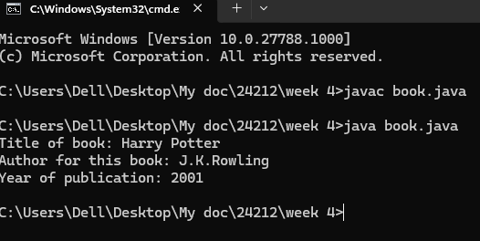
Error:
S.No | Error type | Reason for error
1 | Runtime error | error: file not found: book.java  Usage: javac <options> <source files>  use --help for a list of possible options

CLASS DIAGRAM
Book
- title: String
- author: String
- year: int
Book(String, String, int)
+ displayDetails(): void

IMPORTANT POINTS:
- count: A static integer variable initialized to 0. This variable keeps track of the number of MyClass instances created. Static variables are shared among all instances of the class.
- pi: A static final double variable initialized to 3.14. This variable holds a constant value for π (pi) and is shared among all instances of the class.
- The constructor MyClass() increments the count variable by 1 each time a new instance of the class is created. This helps in keeping track of the number of instances.

WEEK -5
1)AIM: Create a calculator using the operations including addition, subtraction, multiplication and division using Multilevel Inheritance and display the desired output.
CLASS DIAGRAM:
BasicCalculator
+add(a:double,b:double):double
+subtract(a:double,b:double):double

IntermediateCalculator
+multiply(a:double,b:double):double

ScientificCalculator
+divide(a:double,b:double):double

Program:
class addition
{
public int add(int a, int b)
{
int addition = a+b;
return addition;
}
}
class subtraction extends addition
{
public int sub(int a, int b)
{
int subtraction = a-b;
return subtraction;
}
}
class multiplication extends subtraction
{
public int mult(int a, int b)
{
int multiplication = a*b;
return multiplication;
}
}
class division extends multiplication
{
public int div(int a,int b)
{
int division = a/b;
return division;
}
}
class calculator
{
public static void main(String args[])
{
division obj = new division();
System.out.println("Addition is:"+ obj.add(10,2));
System.out.println ("Subtraction is:"+obj.sub(8,4));
System.out.println("Multiplication is:"+obj.mult(12,4));
System.out.println("Division is:"+obj.div(8,4));

}
}

Output:
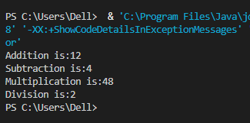

Error:
S.No | Error type | Reason for error
1. | Syntax | Bsec.java:23:error:illegal character:’\u00a0

Important Points:-
Inheritence:
The concept of OOP where a class inherits the properties and behaviours from
Another class (parent class) which promotes code reusability and hieratchical relationships

Multilevel Inheritence:
This is a type of inheritance in which a class inherited from another class, and
That superclass, in turn, inherits from yet another class, creating a chain of
Inheritance

2) AIM: A vehicle rental company wants to develop a system that maintains information about different types of vehicles available for rent. The company rents out cars and bikes and they need a program to store details about each vehicle such as brand and speed
• Cars should have an additional property: number of doors
• Bike should have a property indicating whether they have gears or not
• The system should also include a function to display details about each vehicle and indicate when a vehicle is starting
• Every class should have a constructor
1. Which OOP concept is used in the above program? Explain why it is useful in this scenario.
2. If the company decides to add a new type of vehicle truck, how would you modify the program? Truck should include an additional property capacity(in tons). Create a showTruckDetails() method to display the truck’s capacity. Write a constructor for truck that initializes all properties.
3. Implement the truck class and update the main method to create a truck object, also create an object for car and bike subclassed. Finally display its details.
CLASS DIAGRAM:
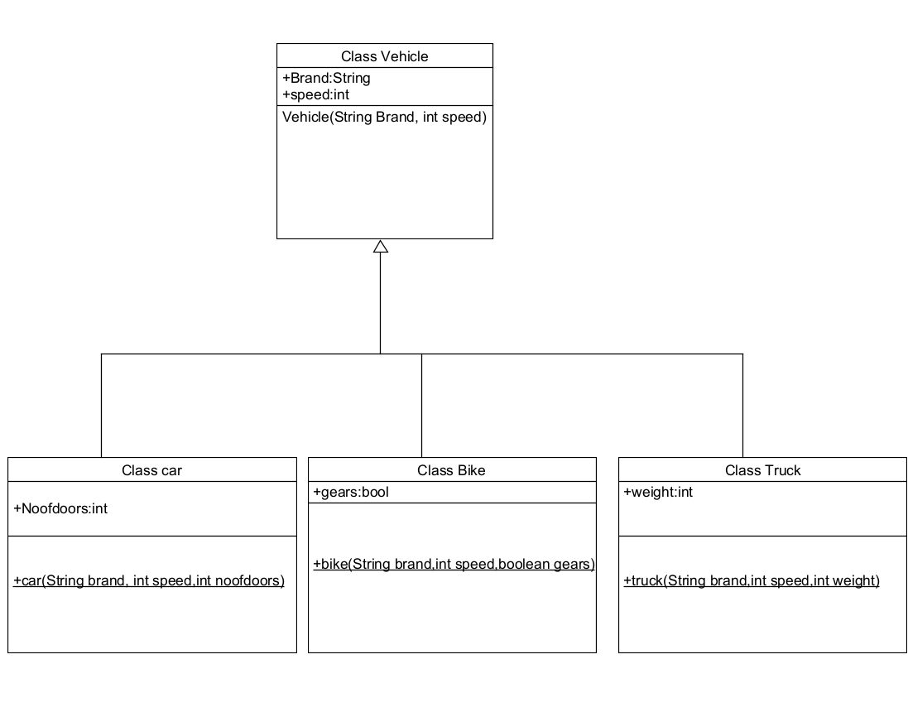

Program:
class Vehicle {
String brand;
int speed;

public Vehicle(String brand, int speed) {
this.brand = brand;
this.speed = speed;
}

public static void main(String[] args) {
Car obj1 = new Car("Ford", 34, 4);
Bike obj2 = new Bike("Hero", 100, true);
Truck obj3 = new Truck("Tata", 60, 40);
}
}

class Car extends Vehicle {
int noOfDoors;

public Car(String brand, int speed, int noOfDoors) {
super(brand, speed);
this.noOfDoors = noOfDoors;
System.out.println("Brand of car is: " + brand);
System.out.println("Speed of car is: " + speed);
System.out.println("No of doors of car: " + noOfDoors);
}
}

class Bike extends Vehicle {
boolean gears;

public Bike(String brand, int speed, boolean gears) {
super(brand, speed);
this.gears = gears;
System.out.println("Brand of bike is: " + brand);
System.out.println("Speed of bike is: " + speed);
System.out.println("Gears of bike: " + gears);
}
}

class Truck extends Vehicle {
int weight;

public Truck(String brand, int speed, int weight) {
super(brand, speed);
this.weight = weight;
System.out.println("Brand name is: " + brand);
System.out.println("Speed of Truck is: " + speed);
System.out.println("Weight of load is: " + weight);
}
}

Output:
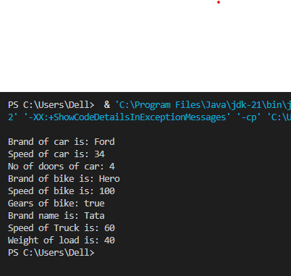
NEGATIVE CASE:
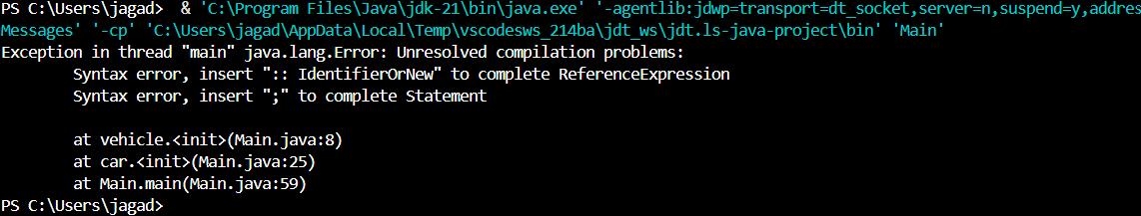

ERROR TABLE:-
S No | Error Type | Cause | Rectification
1 | Syntax Error | Semicolon missing | Added ;

Important Points
Hierarchical Inheritence:
This is a type of inheritance occurs when multiple subclasses inherit from a
Single parent class

ERROR:

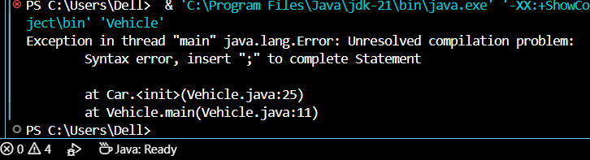
WEEK- 6
1)AIM: Write a java program to create a Vehicle class with a method displayInfo(). Override this method in the Car subclass to provide specific information about a car.
CLASS DIAGRAM:
vehicle
+displayinfo():void

car
Color:String
Speed:int
Model:String
Type:String
Fueltype:String
+displayInfo():void

Program:
class vehicle{
String company;
String model;
String fuel;
int capacity;
void displayInfo(String company,String model,String fuel,int capacity){
System.out.println("The details of vehicle: ");
this.company=company;
this.model=model;
this.fuel=fuel;
this.capacity=capacity;
}
}

class car extends vehicle{

void displayInfo(String company,String model,String fuel,int capacity){
System.out.println("Company: "+company);
System.out.println("Model: "+model);
System.out.println("Fuel: "+fuel);
System.out.println("Capacity: "+capacity);
}
}
class poly1{
public static void main(String[] args){
car car1=new car();
car1.displayInfo("Audi","Model","Diesel",4);
}
}
Output:
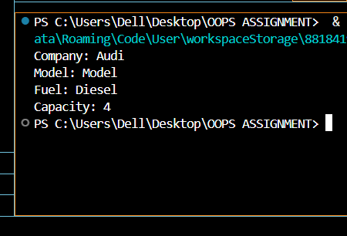
NEGATIVE CASE:

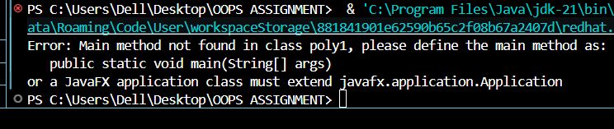

ERRORS :
S.No | Error type | Reason for error | Rectification
1 | Syntax error | [] is missed | [] is added
2 | Logical error | Incorrect logic | Correct logic

2) A college is developing an automated admission system that verifies students eligibility for undergraduate(UG) and postgraduate(PG) programs. Each program has different eligibility criteria based on the student's percentage in their previous qualification.
UG Admissions require a minimum of 60%.
PG Admissions require a minimum of 70%.
Program:
class College{
String name;
int percentage;
void geteligibility(String name,int percentage){
this.name=name;
this.percentage=percentage;
}
}
class UG extends College{
void geteligibility(String name,int percentage){
if (percentage>=60){
System.out.println(name+" is eligible");
}
else{
System.out.println(name+" is not eligible");
}
}
}
class PG extends College{
void geteligibility(String name,int percentage){
if (percentage>=70){
System.out.println(name+" is eligible");
}
else{
System.out.println(name+" is not eligible");
}
}
}
class poly2{
public static void main(String[] args){
UG ug=new UG();
ug.geteligibility("Person-1",40);
PG pg=new PG();
pg.geteligibility("Person-2",80);
}
}

Output:
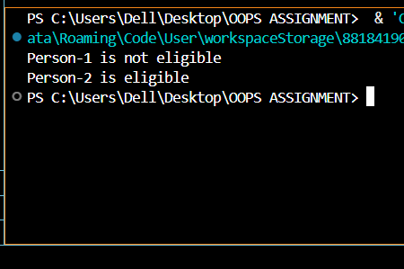
NEGATIVE CASE:
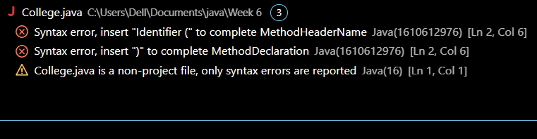

ERROR :
S.No | Error type | Reason for error | Rectification
1 | syntax error | String forgot in main function | String is added
2 | Logical error | Incorrect logic | Correct logic

Class Diagram:
Student
- name: String
- percentage: double
+ Student(String, double)
+ getName(): String
+ getPercentage(): double

AdmissionSystem
+ isEligibleForUG(Student): boolean
+ isEligibleForPG(Student): boolean

AdmissionSystemDemo
+ main(S
3) AIM: Create a Calculator class with overloaded methos to perform addition:
i) Add two integers
ii) Add two doubles
iii) Add three integers
CLASS DIAGRAM:
Calculator1
+ add(int, int)
+ add(double, dbl)
+ add(int,int,int)
Solution
+main(String[])

Program:
class Calcee{

public int add(int a,int b){
return a+b;
}
public double add(double a,double b){
return a+b;
}
public int add(int a,int b,int c){
return a+b+c;
}
}
class poly3{
public static void main(String[] args){
Calcee C1=new Calcee();
System.out.println("Sum of 2 and 5 is: "+C1.add(2,5));
System.out.println("Sum of 3.2 and 6.5 is: "+C1.add(3.2,6.5));
System.out.println("Sum of 2,5 and 3 is: "+C1.add(2,5,3));
}
}
OUTPUT :
POSITIVE CASE:

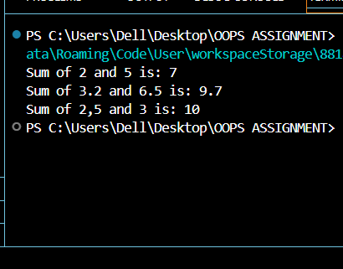

NEGATIVE CASE:

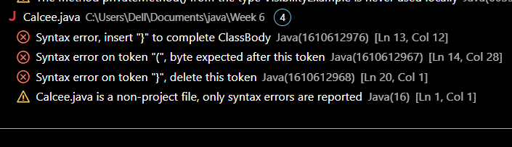

ERROR :
S.No | Error type | Reason for error | Rectification
1 | syntax error | String forgot in main function | String is added
2 | Logical error | Incorrect logic | Correct logic

Class Diagram:
Calculator
+ add(int, int): int
+ add(double, double): double
+ add(int, int, int): int

CalculatorDemo
+ main(String[]): void

4)AIM: Create a shape class with a method calculateArea() that is overloaded for different shapes (e.g square,rectangle). Then create a subclass Circle that overrides the calculteArea().
Class Diagram:
Shape
+calculateArea(double)
+calculateArea(2 doubles)
+calculateArea(2d, String)

Circle
-PI: double |
+calculateArea(double)

ShapeAreaCalculator
+main()

Program:
class Shape {
public double calculateArea(double side) {
return side * side;
}

public double calculateArea(double length, double width) {
return length * width;
}
}

class Circle extends Shape {
public double calculateCircleArea(double radius) {
return Math.PI * radius * radius;
}
}

public class ShapeDemo {
public static void main(String[] args) {
Shape shape = new Shape();
Circle circle = new Circle();

double squareArea = shape.calculateArea(4.0);
System.out.println("Area of square (side = 4.0): " + squareArea);

double rectangleArea = shape.calculateArea(5.0, 3.0);
System.out.println("Area of rectangle (length = 5.0, width = 3.0): " + rectangleArea);

double circleArea = circle.calculateCircleArea(3.0);
System.out.println("Area of circle (radius = 3.0): " + circleArea);

System.out.println("\nDeveloped by Gaurav");
}
}
Output: 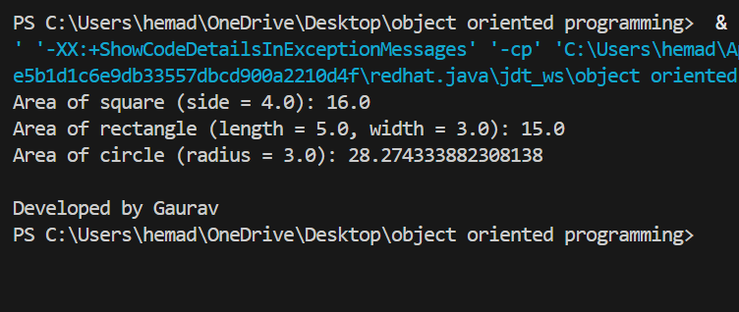

Negative case:
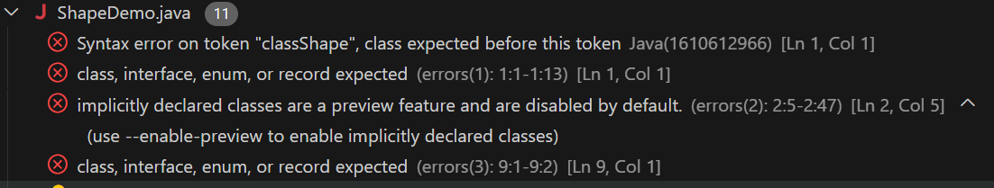

AIM:A college is developing an automated admission system that verifies student’s eligibility for Undergraduate(UG) and Postgraduate(PG) programs. Each program has different eligibility criteria based on the student’s percentage in their previous qualification.
CONDITION:
1.UG admission require minimum of 60%,PG admission require minimum of 70%.

CLASS DIAGRAM:
Student
- name: String
- percentage: double
+ Student(name, percentage)
+ Eligibility(): void

UG
+ UG(name, percentage) + Eligibility(): void
PG
+ PG(name, percentage) + Eligibility(): void

PROGRAM:
class Student {
protected String name;
protected double percentage;

Student(String name, double percentage) {
this.name = name;
this.percentage = percentage;
}

public void Eligibility() {
System.out.println(name + " must meet the general admission criteria");
}
}

class UG extends Student {
UG(String name, double percentage) {
super(name, percentage);
}

@Override
public void Eligibility() {
if (percentage > 59) {
System.out.println(name + " is eligible for UG admission");
} else {
System.out.println(name + " is Not eligible for UG admission");
}
}
}

class PG extends Student {
PG(String name, double percentage) {
super(name, percentage);
}

@Override
public void Eligibility() {
if (percentage > 69) {
System.out.println(name + " is eligible for PG admission");
} else {
System.out.println(name + " is Not eligible for PG admission");
}
}
}

public class Admission {
public static void main(String[] args) {
UG ug = new UG("BARFI", 70);
PG pg = new PG("BUNNY", 59);
ug.Eligibility();
pg.Eligibility();
}
}
Output:
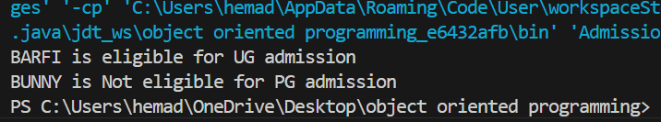
Negative case:
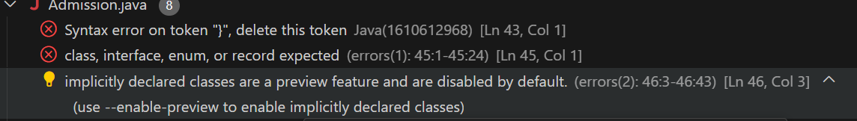
ERROR TABLE:
S.NO | ERROR | RECTIFICATION
1 | java.lang.error | By adding ‘ ; ’

IMPORTANT POINTS:
- Method Overriding: UG and PG override the Eligibility() method from Student.
- Constructor Chaining: super() is used to initialize base class fields
- Protected Access: name and percentage are protected, accessible in child classes.
- Eligibility Logic: Different admission criteria are applied for UG (>59%) and PG (>69%).

